**WaterSaver System**

**by**

**Group Hitsuraan**

**Developers:**

**But-anon, Judilyn S.**

**Laborada, Grace P.**

**Laurente, Rangie**

**Paller, Mary Jane C.**

**Submitted: 10-12-2019**

**Mr. Jun Rey Ansing**

**Course Instructor**

Acknowledgments

Foremost,we permit our entire gratitude and praises to the almighty God for the showered blessings and shown guidance throughout the making of this system to be successful.

Besides,we the developers would like to express our profound gratitude to our subject adviser -Sir Jun Rey Ansing for his motivation, immense knowledge, suggestions for our quest for knowledge, and ceaseless support.

Our sincere thanks also is granted to the Passerelles Numeriques Organization for their dynamism,support,and providing us the time and all the resources in making this system to work and be possible.

Special thanks also to our Education Management for willingly supporting us by giving us enough time to use the computer laboratory and providing us enough facilities in making this project and understanding our needs.

Lastly, we would like to extend our gratitude to our classmates and friends who were there helping us answer our queries and doubts along the making of this system.

Abstract

Water is the most important natural resource made by mother earth to the humans. It is essential for the existence of life and maintaining ecological balance. Without water, no one on earth will survive. Thus, we need to conserve water. Conserving water means using our water supply wisely and responsibly and conserving water includes reducing water wastage. Overflow of water from tank is one of the major reasons for wastage of water. To monitor the level of water in the tank, we made a model named Water Tank Monitoring System that helps to reduce water wastage. This system is applicable when monitoring multiple tank. Water Tank Monitoring System helps resolve the problem with the use of Soil Moisture Sensor and Laser Transmitter Sensor. Soil Moisture Sensor is used to detect the water and the Laser Transmitter Sensor is used as an indicator if the machine is running or not. User can control the machine through the user interface. The system relies on raspberry pi and these two sensors.

Table of Contents

System Overview..........................................................................................................................5

Scope:...............................................................................................................................7

System Functions.........................................................................................................................8

Use Case Diagram:...........................................................................................................8

Use Case Descriptions………………………………………………………………………….9

GUI Mockups…………………………………………………………………………………...11

Report Formats:..............................................................................................................12

Physical Environment and Resources........................................................................................14

Special Constraints:........................................................................................................14

System Architecture & Design....................................................................................................15

Architectural Design........................................................................................................15

Class Diagram.................................................................................................................16

Sequence Diagram..........................................................................................................17

Entity Relationship Diagram............................................................................................18

Work Breakdown Structure……………………………………………………………………19

Appendices..................................................................................................................................20

System Overview

Water is a limited resource and is essential in all aspects of living. Many people don’t realize the true importance of water everyday. More water is wasted by many uncontrollable way. This problem is quietly related to poor water allocation, inefficient use, and lack of adequate and integrated water management. Therefore, efficient use and water monitoring are potential constraints for managing multiple water tank or even for home or office water tank.

Water Tank Monitoring is used to avoid overflowing and intimate level of water in the tank. With the help of IoT (Internet of Things) and raspberry pi sensors, it enables us to build a system without human interference. Water Tank Monitoring System used Soil Moisture Sensor and Laser Transmitter Sensor. A Laser Transmitter Sensor is a device that emits light through a process of optical amplification based on the stimulated emission of electromagnetic radiation, but in this model the Laser Transmitter Sensor is used as an indicator if the machine is running or not.The Laser Transmitter is on if the machine is running and off if not. Soil Moisture Sensor is used to measure the volume of water content of soil, but in this project, Soil Moisture Sensor is used to detect the level of water in the tank. The sensor will be put in the upper part of the tank. Every data collected by the sensors will be sent to the person who monitors the tank. All data can be seen through the User Interface of the system. User also can control the machine through the user interface to ease the hassle.

System Objectives

The main objectives of this system is to reduce water wastage and to promote water conservation through digital solution. It also aims to help those persons who monitor the tank easily and quickly.

In order to fulfill its intended purpose, this system must meet the following objectives:

* The system must work at real time
* System Availability
* The system must deliver accurate data
* Can control machine switch through the user interface

Scope and Limitations

The system aims to automate the process of water tank monitoring with the use of Raspberry Pi and Sensors to gather data.

Scope:

* Only capable for python and linux
* Can detect water level depends on what level of the tank you placed the sensor.
* Send every data detected by the sensor to the user.
* User can see the data through web or the UI
* Switch of the machine can be controlled through the web or UI.

Limitations:

Though the system presents a broad range of options to its users, some intricate options could not be covered into it. These are the list of limitations available in the Water Tank Monitoring System:

* Need Larger Storage
* Need internet connection

System Functions

This picture below is the user interface of the WaterSaver system where tha data sent from the sensor can be seen. User also can control the machine switch through the interface.

GUI Mockups:

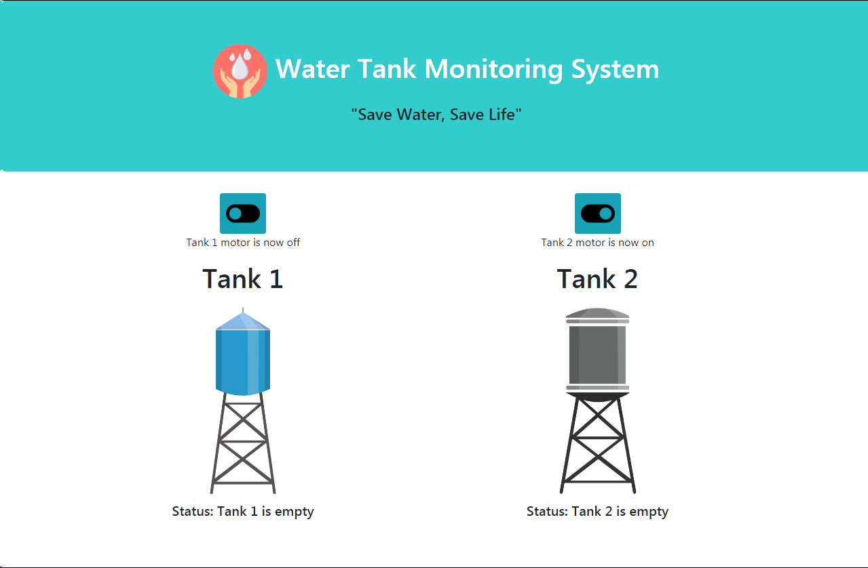

System Functions

System Architecture and Design:

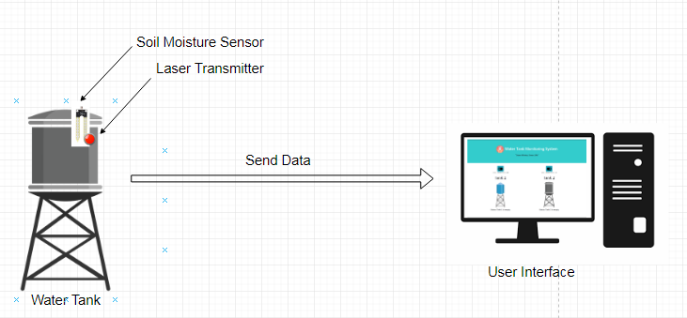

Physical Environment and Resources

Minimum System Requirements:

This section lists the minimum hardware and software requirement to properly execute the system.To run the system, you need to have these following :

Hardware Interface:

* Raspberry Pi 3
* Soil Moisture Sensor
* Laser Transmitter Sensor
* Bread Board
* Wire Jumper

Software Interface:

* Operating System : Linux
* Programming Language : Python
* Internet Access
* WinSCP
* PuTTy

Disclaimers – Intellectual Property

< Throughout the course of making this project, it is highly anticipated that the developers had to or opted to use third party items such as (but not limited to): plug-in codes, images, templates, frameworks, image, video, audio files. It is in this portion of the document that the developers must document by listing down these items, their sources, and their licenses.>

|  |  |  |  |
| --- | --- | --- | --- |
| Item | Source | License | Remarks |
|  |  |  |  |
|  |  |  |  |
|  |  |  |  |
|  |  |  |  |
|  |  |  |  |
|  |  |  |  |